Android Lab Cycle 1

1. Design an application for the login page using .xml file.

<?xml version="1.0" encoding="utf-8"?>  
<LinearLayout xmlns:android="http://schemas.android.com/apk/res/android"  
 android:orientation="vertical" android:layout_width="match_parent"  
 android:layout_height="match_parent">  
 <TextView  
 android:id="@+id/loginscrn"  
 android:layout_width="wrap_content"  
 android:layout_height="wrap_content"  
 android:layout_marginTop="80dp"  
 android:text="Login"  
 android:textSize="25dp"  
 android:textStyle="bold"  
 android:layout_gravity="center"/>  
 <TextView  
 android:id="@+id/fstTxt"  
 android:layout_width="wrap_content"  
 android:layout_height="wrap_content"  
 android:layout_marginLeft="100dp"  
 android:layout_marginTop="20dp"  
 android:text="Email"/>  
 <EditText  
 android:id="@+id/txtEmail"  
 android:layout_width="wrap_content"  
 android:layout_height="wrap_content"  
 android:layout_marginLeft="100dp"  
 android:ems="10"/>  
 <TextView  
 android:id="@+id/secTxt"  
 android:layout_width="wrap_content"  
 android:layout_height="wrap_content"  
 android:text="Password"  
 android:layout_marginLeft="100dp" />  
 <EditText  
 android:id="@+id/txtPwd"  
 android:layout_width="wrap_content"  
 android:layout_height="wrap_content"  
 android:layout_marginLeft="100dp"  
 android:inputType="textPassword"  
 android:ems="10" />  
 <Button  
 android:id="@+id/btnLogin"  
 android:layout_width="wrap_content"  
 android:layout_height="wrap_content"  
 android:layout_marginLeft="100dp"  
 android:text="Login" />  
  
</LinearLayout>

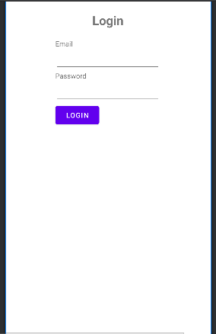

1. Develop an application for a simple registration page using .xml file.

<?xml version="1.0" encoding="utf-8"?>  
<LinearLayout xmlns:android="http://schemas.android.com/apk/res/android"  
 android:orientation="vertical" android:layout_width="match_parent"  
 android:layout_height="match_parent">  
 <TextView  
 android:id="@+id/loginscrn"  
 android:layout_width="wrap_content"  
 android:layout_height="wrap_content"  
 android:layout_marginTop="80dp"  
 android:text="Registration"  
 android:textSize="25dp"  
 android:textStyle="bold"  
 android:layout_gravity="center"/>  
 <TextView  
 android:id="@+id/fstTxt"  
 android:layout_width="wrap_content"  
 android:layout_height="wrap_content"  
 android:layout_marginLeft="100dp"  
 android:layout_marginTop="20dp"  
 android:text="Full Name"/>  
 <EditText  
 android:id="@+id/txtName"  
 android:layout_width="wrap_content"  
 android:layout_height="wrap_content"  
 android:layout_marginLeft="100dp"  
 android:ems="10"/>  
 <TextView  
 android:id="@+id/secTxt"  
 android:layout_width="wrap_content"  
 android:layout_height="wrap_content"  
 android:text="Email"  
 android:layout_marginLeft="100dp" />  
 <EditText  
 android:id="@+id/txtEmail"  
 android:layout_width="wrap_content"  
 android:layout_height="wrap_content"  
 android:layout_marginLeft="100dp"  
 android:ems="10" />  
 <TextView  
 android:id="@+id/thirdTxt"  
 android:layout_width="wrap_content"  
 android:layout_height="wrap_content"  
 android:text="Password"  
 android:layout_marginLeft="100dp" />  
 <EditText  
 android:id="@+id/txtPwd"  
 android:layout_width="wrap_content"  
 android:layout_height="wrap_content"  
 android:layout_marginLeft="100dp"  
 android:inputType="textPassword"  
 android:ems="10" />  
 <Button  
 android:id="@+id/btnLogin"  
 android:layout_width="wrap_content"  
 android:layout_height="wrap_content"  
 android:layout_marginLeft="100dp"  
 android:text="Register" />  
  
</LinearLayout></androidx.constraintlayout.widget.ConstraintLayout>

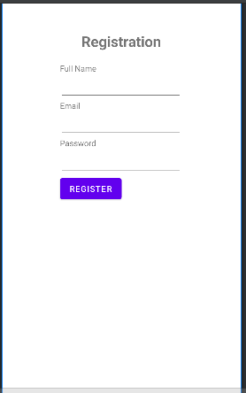

1. Design a simple calculator, and set properties using .xml file.
2. <?xml version="1.0" encoding="utf-8"?>  
   <LinearLayout xmlns:android="http://schemas.android.com/apk/res/android"  
    xmlns:app="http://schemas.android.com/apk/res-auto"  
    xmlns:tools="http://schemas.android.com/tools"  
    android:layout_width="match_parent"  
    android:layout_height="match_parent"  
    tools:context=".MainActivity"  
    android:padding="20dp"  
    android:orientation="vertical"  
    android:background="@color/pastel">  
     
    <TextView  
    android:layout_width="wrap_content"  
    android:layout_height="wrap_content"  
    android:text="CALCULATOR"  
    android:textSize="25sp"  
    android:layout_marginBottom="16dp"  
    android:textColor="@android:color/black" />  
     
    <LinearLayout  
    android:layout_width="match_parent"  
    android:layout_height="wrap_content"  
    android:orientation="horizontal"  
    android:layout_marginBottom="20dp">  
     
    <EditText  
    android:id="@+id/first_no"  
    android:layout_width="102dp"  
    android:layout_height="59dp"  
    android:ems="10"  
    android:layout_marginHorizontal="50dp"  
    android:hint="Enter" />  
     
    <EditText  
    android:id="@+id/second_no"  
    android:layout_width="102dp"  
    android:layout_height="59dp"  
    android:ems="10"  
    android:hint="Enter" />  
     
    </LinearLayout>  
     
    <LinearLayout  
    android:layout_width="wrap_content"  
    android:layout_height="wrap_content"  
    android:orientation="horizontal"  
    android:layout_marginBottom="20dp">  
     
    <TextView  
    android:textSize="35sp"  
    android:id="@+id/answer"  
    android:layout_width="102dp"  
    android:layout_height="59dp"  
    android:layout_marginHorizontal="50dp"  
    android:hint="ans" />  
     
    </LinearLayout>  
     
    <LinearLayout  
    android:orientation="vertical"  
    android:layout_marginLeft="250dp"  
    android:layout_width="wrap_content"  
    android:layout_height="wrap_content"  
    android:layout_marginBottom="30dp">  
     
    <Button  
    android:id="@+id/sub"  
    android:layout_width="wrap_content"  
    android:layout_height="wrap_content"  
    android:text="-"  
    android:textSize="25sp"  
    android:layout_marginBottom="16dp" />  
     
    <Button  
    android:id="@+id/add"  
    android:layout_width="wrap_content"  
    android:layout_height="wrap_content"  
    android:layout_marginBottom="16dp"  
    android:text="+"  
    android:textSize="25sp"  
    tools:ignore="OnClick" />  
     
    <Button  
    android:id="@+id/div"  
    android:layout_width="wrap_content"  
    android:layout_height="wrap_content"  
    android:text="/"  
    android:textSize="25sp"  
    android:layout_marginBottom="16dp" />  
     
    <Button  
    android:id="@+id/mul"  
    android:layout_width="wrap_content"  
    android:layout_height="wrap_content"  
    android:layout_marginBottom="16dp"  
    android:text="X"  
    android:textSize="25sp"/>  
     
    <Button  
    android:id="@+id/equals"  
    android:layout_width="wrap_content"  
    android:layout_height="wrap_content"  
    android:layout_marginBottom="16dp"  
    android:text="="  
    android:textSize="35sp"/>  
    </LinearLayout>  
     
     
   </LinearLayout>

